**“THEY”: Global sustainability and circular economy**

**“他们”：全球可持续发展和循环经济**

**Module Four Booklet**

第4模块课程手册

1 Brief

简介

2 Final Deliverable

最终产出

3 Reference

参考资料

4 Key takeaway week1

第一周概述

5 Key takeaway week2

第二周概述

6 Key takeaway week3

第三周概述

**Brief 简介**

The goal of this module is to help students build a systemic and sustainable worldview. Through seminars, workshop and museum visits, we will focus on creative projects that can impact not only individuals, but also organization, society and human being at large. We will study thesustainability goals and circular economy in particular, learn from the cases from food system and develop skills of project framing. Students will work in teams and design a projectthatis sustainable and fulfill practical, and emotional aspects of daily food consumption at school. We will explore tangible and intangible aspectsincluding human interactions, services, and systems, all of which help to understand the systemic relationship and the sustainable

课程的目的是帮助同学们初步建立系统性思维和可持续发展的世界观。通过讲座、工作坊和博物馆参观等教学活动，我们将介绍对个人、机构、社会乃至全人类产生影响的创新项目。我们将要了解可持续发展目标和循环经济的基本知识，学习在可持续发展视角下的食物领域的优秀案例，以及实践如何设计一个研究项目。最终，同学们以小组形式设计一个可持续的校园食物链相关项目，这个食品项目既满足学校日常功用要求，又满足情感需求。通过该项目，我们探索人际间关系、服务和系统等多方面内容，从而帮助我们加深对系统性和可持续发展的理解。

**Key takeaways:**

**要点**：

1. Have an overview of the sustainable goals and the underpinning thinking

对可持续发展目标和背后的思考有初步了解

1. Understand the circular economy logic and practices

理解循环经济的原理和应用

1. Identify the research question and develop it to frame a research project

学习发现问题和设计研究项目

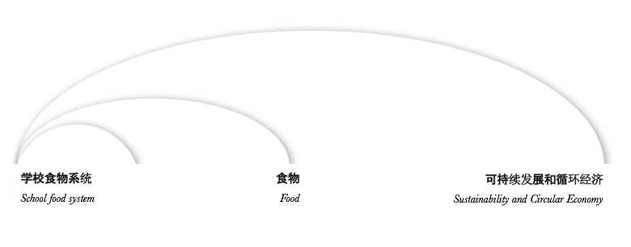

**Final deliverable:**

**最终产出：**

A research project proposal that explains how you are going to tackle the food problem/ or improve the food system at your school to make it more sustainable.

研究项目提案。在提案中阐明影响校园可持续食物系统的问题，以及接下来将如何进行进一步研究。

Pitch your project:

推介你的项目：

向“投资人”介绍你的研究项目，争取得到投资人拿出手中的资金哦。

**Readings**

**参考资料**

**Wicked problem and System thinking**

Buchanan, Richard, “Wicked Problems in Design Thinking.” *Design Issues.*

**Circular Economy**

Ellen MacArthur Foundation:[**https://www.circulareconomy.com**](https://www.circulareconomy.com)

**Food cases**

<http://www.desisnetwork.org/the-desis-map/>

<https://foodtank.com>

**Other Materials**

**其它资料**

Films

Saul Bass and Associates, “Why Man Creates.” 1968. (short feature; 25 minutes)

“Between the Folds,” Green Fuse Films, 2009. (55 minutes)

“The Deep Dive,” ABC NEWS, 07/13/1999 (short feature)

“Jimmy’s Food Factory”, 2009, BBC (documentary)

**Syllabus**

**课程安排**

**WEEK 1**

**第一周**

**What: Learning about the sustainable development, circular economy and the technocyle**

**目标：**对可持续发展目标和背后的思考有初步了解；了解循环经济和“科技链”

**Task: The analysis of the after-effect of “Double 11” Shopping festival**

**小组产出：“双11”购物后的反思**

**WEEK 2**

**第二周**

**What: Learning about the biocylce of circular economy and food cases for inspiration**

**目标：了解循环经济的“生物循环“；学习可持续发展视角下的食物领域案例**

**Task: Mapping your school food system and exploring the problematic spot in the system**

**小组产出：学校现有食物体统／链；以及小组想要处理的问题**

**WEEK 3**

**第三周**

**What: Question inquiry and designing a research project**

**目标：学习发现问题和制作研究计划**

**Final Deliverable: pitch your project**

**最终产出：推介你的研究计划提案**

**Module Four Responsible Instructors课程负责人**

Tiina LAURILA

Yubei GONG龚渝蓓

**Date and Time:** 上课日期和时间:

November 20 – December 8, 2017

Time: Monday-Thursday, 2:55 pm – 4:25 pm

Friday, 1:10 pm – 4:10 pm

Place: Shanghai Tongji-Huangpu School of Design and Innovation

地点：上海同济黄浦设计创意中学